CA2-CAP770
Name: Prashant Patil
Roll: 24
Reg: 12527088
BST-Preorder traversal
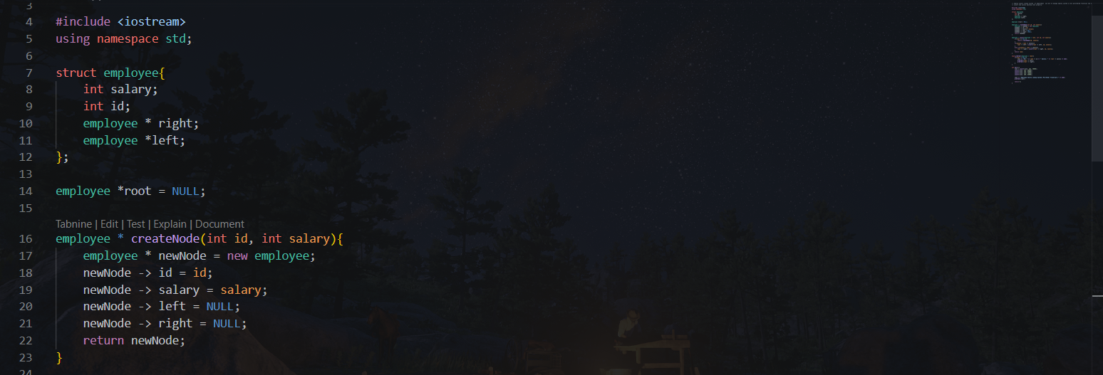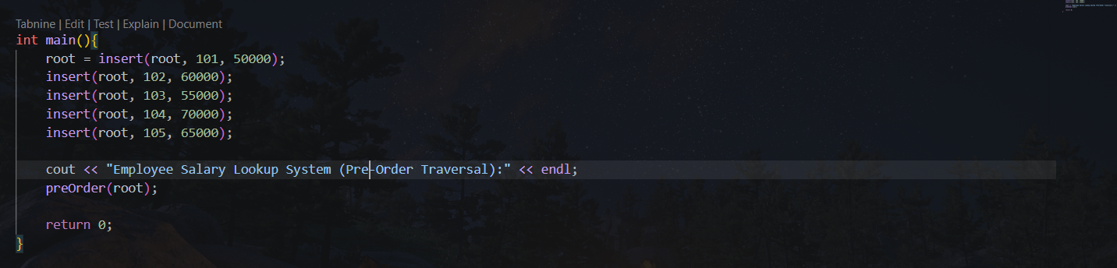

Output:
